Group 13

Author: 任怡静

Software Specifications

Huarong Path

Table of Contents

System Architecture 2

Software Specifications 3

S1: mainMenu implementation 3

S2: mainInterfaceUI Implementation 6

S3: selfMenu implementation 9

## System Architecture

The system architecture is shown below:

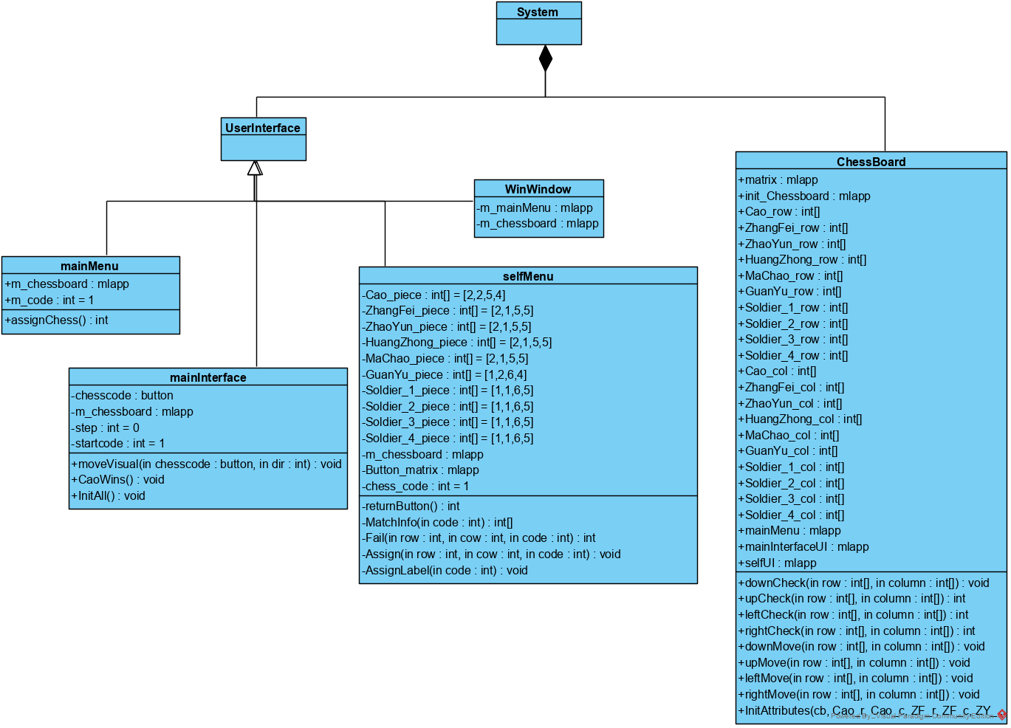

## Software Specifications

### S1: mainMenu implementation

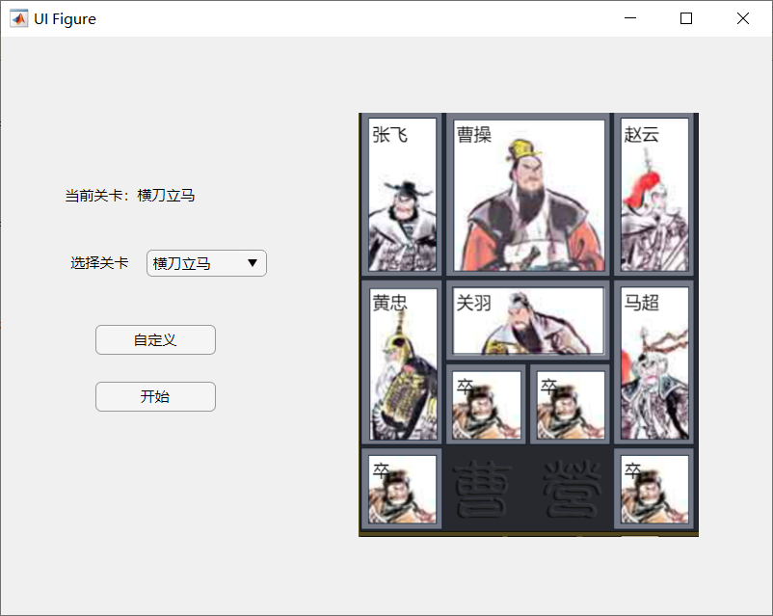

#### S1.1: Select a beginning and Start

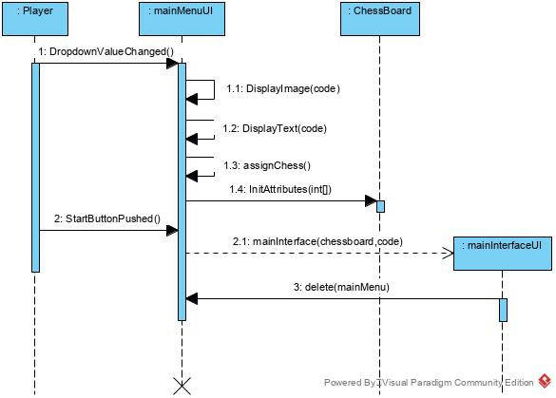

* S1.1.1: Select a beginning

1. Dropdown clicked
2. Image show the corresponding picture
3. Label show the corresponding information

* S1.1.2: Start the game

1. Start button clicked
2. For the last selected Dropdown value
   1. If its code is equal to 1, set the beginning of “横刀立马” for a mainInterfaceUI
   2. If its code is equal to 2, set the beginning of “左右布兵” for a mainInterfaceUI
   3. If its code is equal to 3, set the beginning of “兵分三路” for a mainInterfaceUI
   4. If its code is equal to 4, set the beginning of “兵来将阻” for a mainInterfaceUI
   5. If its code is equal to 5, set the beginning of “层层设防” for a mainInterfaceUI
   6. If its code is equal to 6, set the beginning of “插翅难飞” for a mainInterfaceUI
   7. If its code is equal to 7, set the beginning of “过五关” for a mainInterfaceUI
   8. If its code is equal to 8, set the beginning of “近在咫尺” for a mainInterfaceUI
   9. If its code is equal to 9, set the beginning of “前挡后阻” for a mainInterfaceUI

#### S1.2: Self-design a beginning and Start

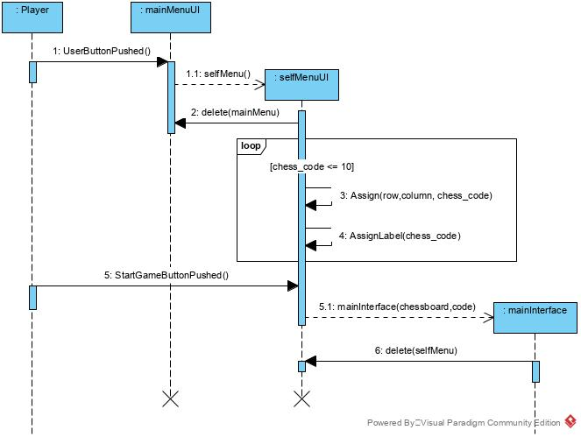

* S1.2.1: Choose “自定义” mode

1. User button clicked

* S1.1.2: Enter selfMenuUI

1. Set chess pieces into places in a specific order
   1. The first chess piece is “曹操“, make sure to assign its start position within Row 1 to 4 and Column 1 to 3, display the chess piece in the corresponding position in the image.
   2. The second chess piece is “张飞“, make sure to assign its start position within Row 1 to 4 and Column 1 to 4, display the chess piece in the corresponding position in the image.
   3. The third chess piece is “赵云“, make sure to assign its start position within Row 1 to 4 and Column 1 to 4, display the chess piece in the corresponding position in the image.
   4. The fourth chess piece is “黄忠“, make sure to assign its start position within Row 1 to 4 and Column 1 to 4, display the chess piece in the corresponding position in the image.
   5. The fifth chess piece is “马超“, make sure to assign its start position within Row 1 to 4 and Column 1 to 4, display the chess piece in the corresponding position in the image.
   6. The sixth chess piece is “关羽“, make sure to assign its start position within Row 1 to 5 and Column 1 to 3, display the chess piece in the corresponding position in the image.
   7. The seventh chess piece is “卒1“, make sure to assign its start position within Row 1 to 5 and Column 1 to 4, display the chess piece in the corresponding position in the image.
   8. The eighth chess piece is “卒2“, make sure to assign its start position within Row 1 to 5 and Column 1 to 4, display the chess piece in the corresponding position in the image.
   9. The ninth chess piece is “卒3“, make sure to assign its start position within Row 1 to 5 and Column 1 to 4, display the chess piece in the corresponding position in the image.
   10. The tenth chess piece is “卒4“, make sure to assign its start position within Row 1 to 5 and Column 1 to 4, display the chess piece in the corresponding position in the image.
2. If reset button is pressed in during the set process, restart the process in 1

* S1.1.3: Start Button clicked
* S1.1.4: Set the beginning of the initiated m_chessboard of selfMenuUI for a mainInterfaceUI

### S2: mainInterfaceUI Implementation

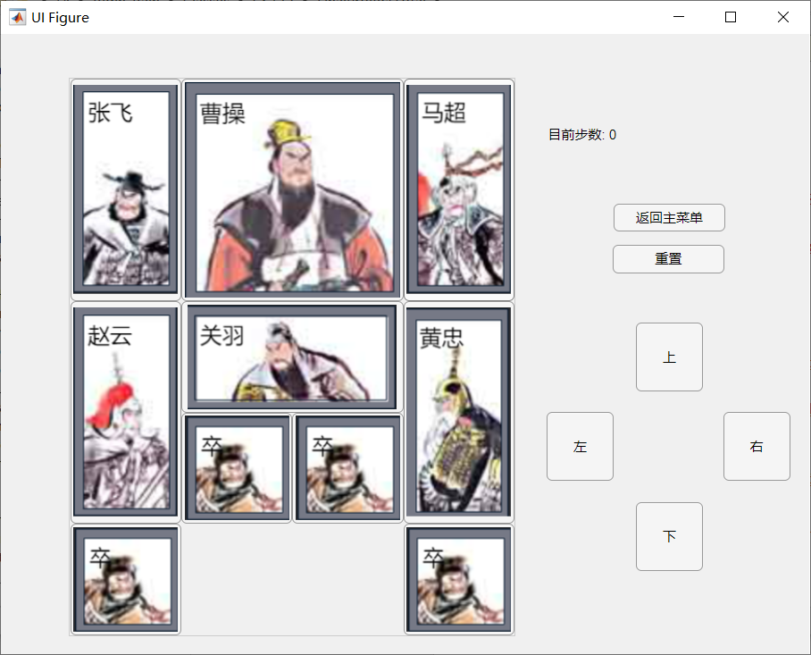

#### S2.1: Play the game

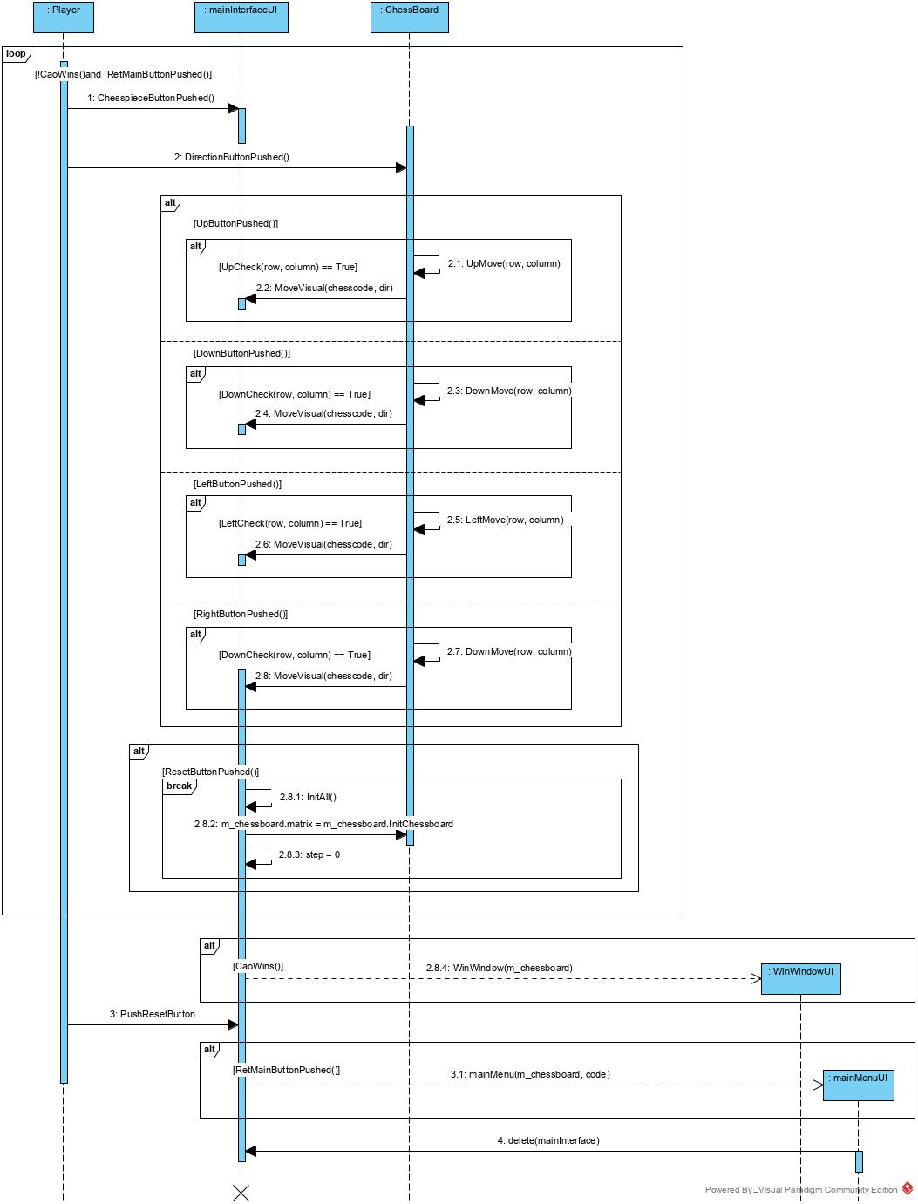

* S2.1.1: Move a chess piece up

1. Chess piece button clicked
2. Up button clicked
3. For the selected chess piece
   1. If the chess piece will not go out of the chess board border, and the chess piece is not intersecting with other chess pieces, update the matrix inside the m_chessboard, also moves the chess piece button for one unit upwards.
   2. Otherwise, no moves will be taken.
4. step increment by 1

* S2.1.2: Move a chess piece down

1. Chess piece button clicked
2. Down button clicked
3. For the selected chess piece
   1. If the chess piece will not go out of the chess board border, and the chess piece is not intersecting with other chess pieces, update the matrix inside the m_chessboard, also moves the chess piece button for one unit downwards.
   2. Otherwise, no moves will be taken.
4. step increment by 1

* S2.1.3: Move a chess piece left

1. Chess piece button clicked
2. Left button clicked
3. For the selected chess piece
   1. If the chess piece will not go out of the chess board border, and the chess piece is not intersecting with other chess pieces, update the matrix inside the m_chessboard, also moves the chess piece button for one unit leftwards.
   2. Otherwise, no moves will be taken.
4. step increment by 1

* S2.1.4: Move a chess piece right

1. Chess piece button clicked
2. Right button clicked
3. For the selected chess piece
   1. If the chess piece will not go out of the chess board border, and the chess piece is not intersecting with other chess pieces, update the matrix inside the m_chessboard, also moves the chess piece button for one unit rightwards.
   2. Otherwise, no moves will be taken.
4. step increment by 1

* S2.1.5: Reset all moves

1. Reset button clicked
2. All Chess piece button will be placed as the mainInterfaceUI had started before.
3. The matrix in m_chessboard will be reset as the mainInterfaceUI started.
4. step will be reset to 0

* S2.1.6: Return to mainMenuUI

1. RetMain button clicked
2. Open the mainMenuUI
3. Close this mainInterfaceUI

* S2.1.5: Win the game

1. Final move been made
2. If chess piece “曹操“ is at Row 4 and 5, Column 2 and 3, Open WinWindowUI

### S3: selfMenu implementation

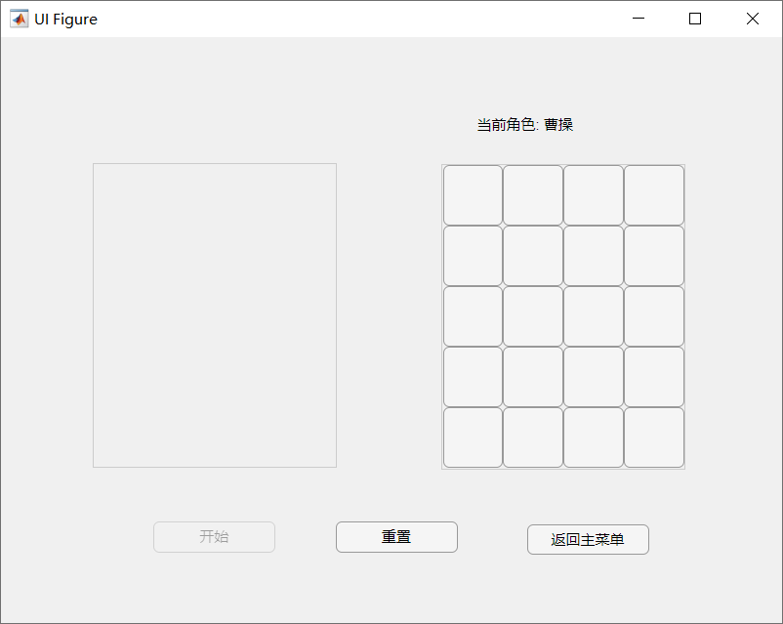

#### S3.1: Set chess pieces into places in a specific order

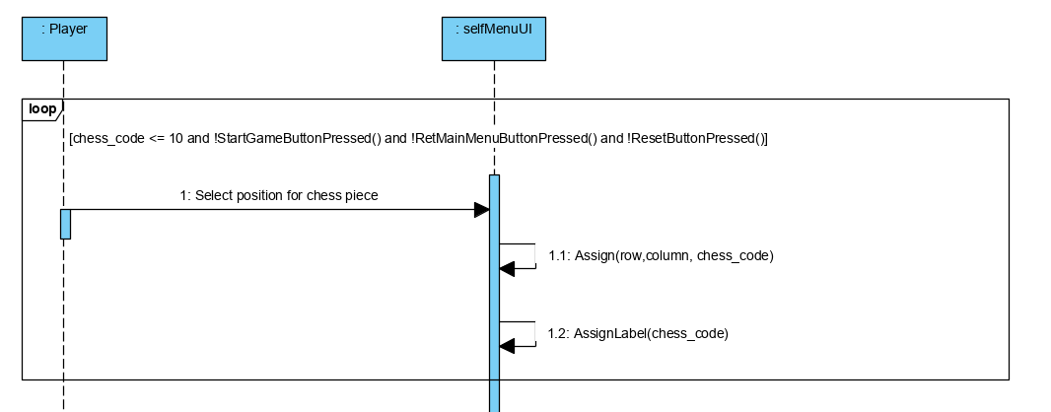

1. The first chess piece is “曹操“, make sure to assign its start position within Row 1 to 4 and Column 1 to 3, display the chess piece in the corresponding position in the image.
2. The second chess piece is “张飞“, make sure to assign its start position within Row 1 to 4 and Column 1 to 4, display the chess piece in the corresponding position in the image.
3. The third chess piece is “赵云“, make sure to assign its start position within Row 1 to 4 and Column 1 to 4, display the chess piece in the corresponding position in the image.
4. The fourth chess piece is “黄忠“, make sure to assign its start position within Row 1 to 4 and Column 1 to 4, display the chess piece in the corresponding position in the image.
5. The fifth chess piece is “马超“, make sure to assign its start position within Row 1 to 4 and Column 1 to 4, display the chess piece in the corresponding position in the image.
6. The sixth chess piece is “关羽“, make sure to assign its start position within Row 1 to 5 and Column 1 to 3, display the chess piece in the corresponding position in the image.
7. The seventh chess piece is “卒1“, make sure to assign its start position within Row 1 to 5 and Column 1 to 4, display the chess piece in the corresponding position in the image.
8. The eighth chess piece is “卒2“, make sure to assign its start position within Row 1 to 5 and Column 1 to 4, display the chess piece in the corresponding position in the image.
9. The ninth chess piece is “卒3“, make sure to assign its start position within Row 1 to 5 and Column 1 to 4, display the chess piece in the corresponding position in the image.
10. The tenth chess piece is “卒4“, make sure to assign its start position within Row 1 to 5 and Column 1 to 4, display the chess piece in the corresponding position in the image.

#### S3.2: Reset all placed chess pieces

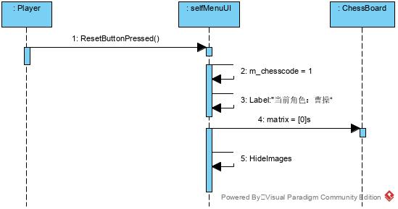

1. m_chesscode = 1, Label text set back to “当前角色：曹操“
2. the matrix in m_chessboard is set to all zero
3. hide all the pictures in the Image

#### S3.2: Start the game

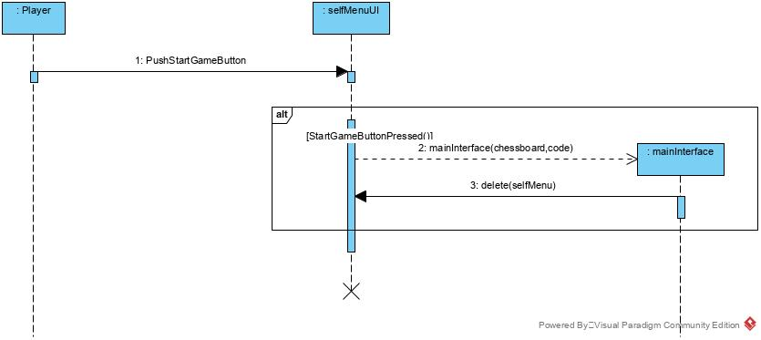

1. StartGame button clicked
2. Open the mainInterfaceUI
3. Close this selfMenuUI

#### S3.2: Return to mainMenuUI

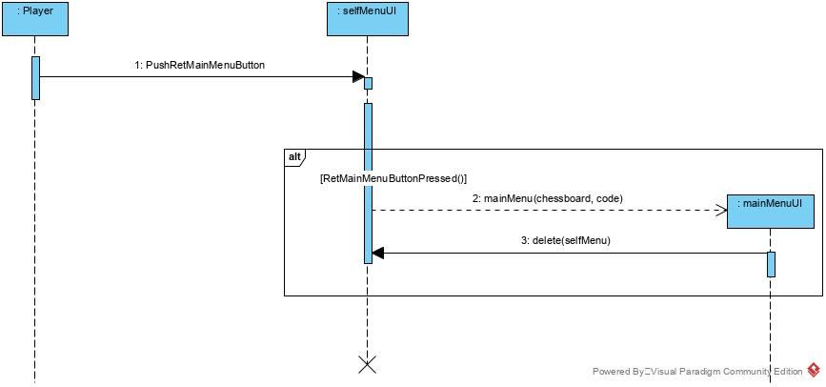

1. RetMain button clicked
2. Open the mainMenuUI
3. Close this selfMenuUI